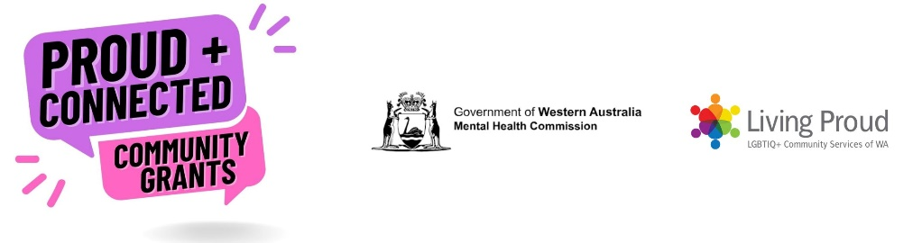
Proud and Connected Community Grants: Application Form
Note: for assistance with completing this application form, please contact our Programs Manager Michael Atkinson (He/Him), on 0418 346 535 or michael@livingproud.org.au
Applicant Information
Primary contact person’s name:
Position title (if relevant):
Group or Organisation name:
ABN (if relevant):
Email:
Telephone:
Website or social media link:
Will you need an Auspicing Body? If yes please provide further details below:

Auspicing Body (If Applicable)
Have you identified an organisation to auspice your activity?
No □ (If no, Living Proud can assist)
Yes □ If yes, please provide the details below:
Name of Organisation:
Primary contact Name:
Position title:
Email:
Telephone:

Activity Information
Title of Activity:

Is this an existing or new activity? Grants can be offered to existing projects in need of additional funding as well as totally new projects.

What is the start and finish dates for your activity:
Start: Finish:

Where will your activity take place? (Town/s, suburbs/s, online, etc)
Please provide a short overall description of your proposed activity. Please be descriptive but brief. In your answer, please include a summary of who this activity is for, what you will do and approximate timeline. (suggested word count 300 words)

Activities must align to one or more of the following four short and intermediate-term outcomes of the WA Suicide Prevention Framework 2021-2025:
- Increased literacy surrounding mental health and wellbeing and suicide prevention
- Decreased stigma associated with mental health issues and suicide
- Increased ability to seek help for oneself or for someone else
- Increased coping skills and ability to manage difficult life experiences.

Please indicate which of the four outcomes your activity aligns with and explain how it aligns (suggested word count 300 words):

Please provide a short summary of the evidence or demonstrated community need for the activity. Evidence of community support is highly regarded as projects driven by community tend to be more successful (suggested word count 300 words).

Are you partnering or collaborating with any groups or organisations to make the activity happen? If yes, please provide the following details for each.

 | Group / Organisation Name | Contact Person | Partner Role | Contact email
Partner 1
Partner 2
Partner 3

How will you promote your activity? (suggested word count 300 words)

How will you evaluate your activity? (suggested word count 300 words)

Is your group/organisation able to monitor activity expenses and complete an acquittal form at the end of your project?
Yes: □ No: □

Living Proud can provide some support to develop, implement, promote and evaluate your activity, if needed. Please list any support you might need (suggested word count 300 words):

Would your group/organisation like assistance to make your activity accessible for LGBTIQA+ people with a disability? We can connect you to Living Proud’s Queer & Accessible Project who can assist with making your activity accessible.

Yes: □ No: □

Does your group/organisation have prior experience developing and implementing activities? Prior experience is not essential. Please list examples (suggested word count 300 words :

Budget

Total Amount Requested:

Total Activity Cost:

Please list activity expense items and amounts below:

Expense Item | Amount
e.g. facilitators, venue hire, program materials, survey development etc
Total amount requested

Have you received any other funding for this activity? Or have you applied for any other funding?

If you are not successful in receiving this grant will your activity still be implemented?

Will this activity continue after this funding finishes?

